**Lesson20 Azure feed feature**

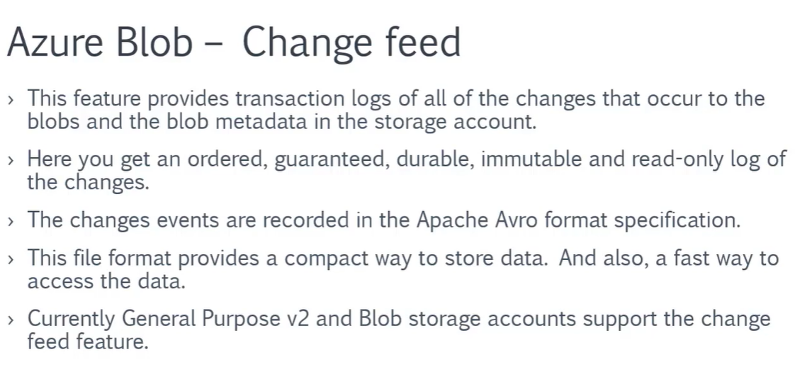

**Steps:-**

**1-on azure storage account > Data Protection > check for feedback option**

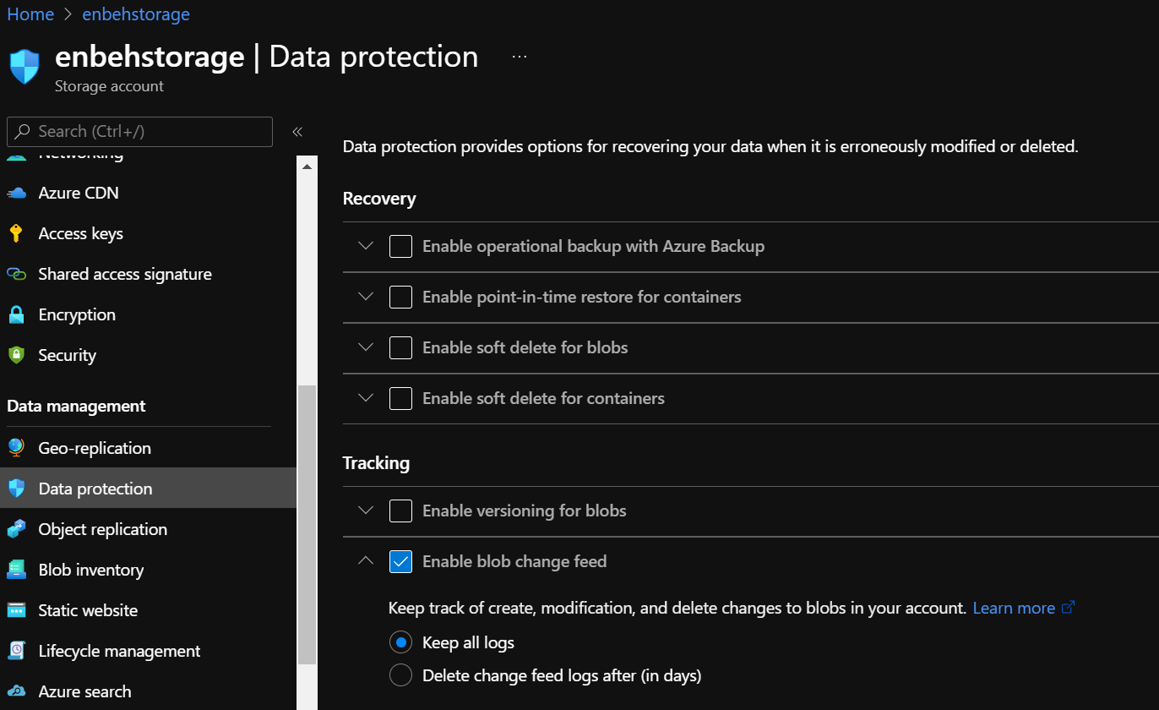

(You will see that it will create new container called $blobchangefeed that used to store append blob used for log files of type .savor)

